B.B MEMORIAL PUBLIC SCHOOL ANNUAL REPORT
2018-19.
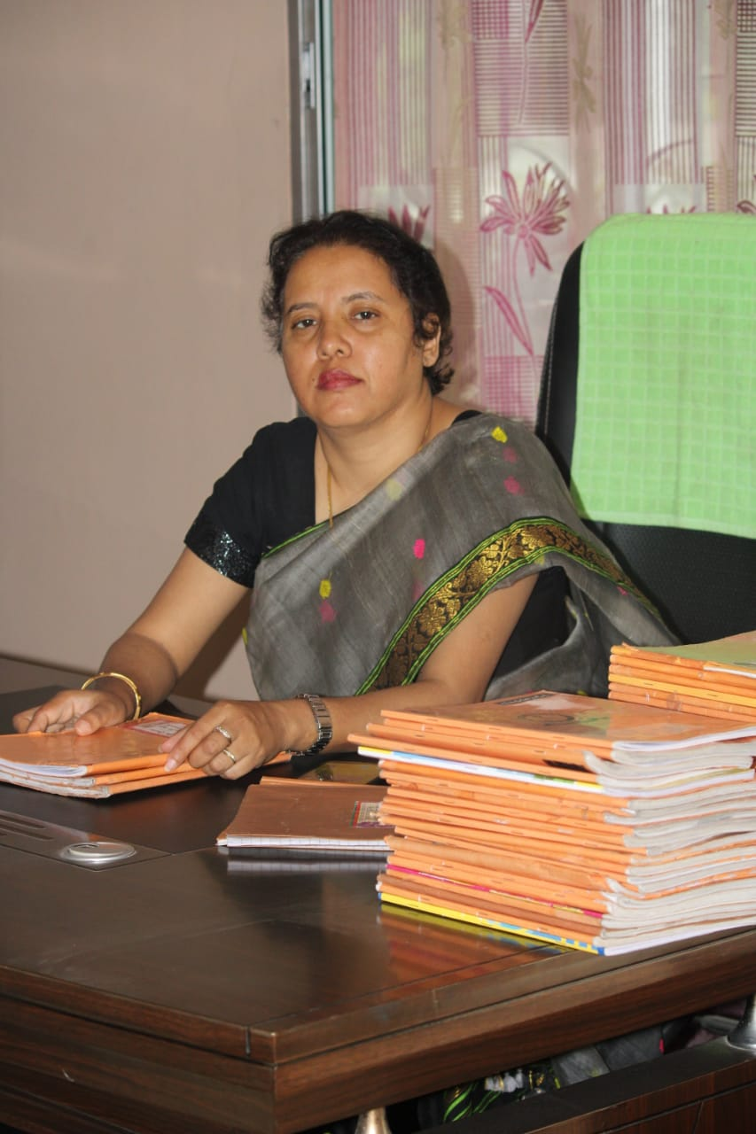
We a proud family of students , teaching and non-teaching staff of B.B.MEMORIAL PUBLIC SCHOOL, TINSUKIA would like to give a few insights into our all year annual activities very briefly.
Achievements
• Our children participated in various quiz and talent search examination where the participants scored a very good position.

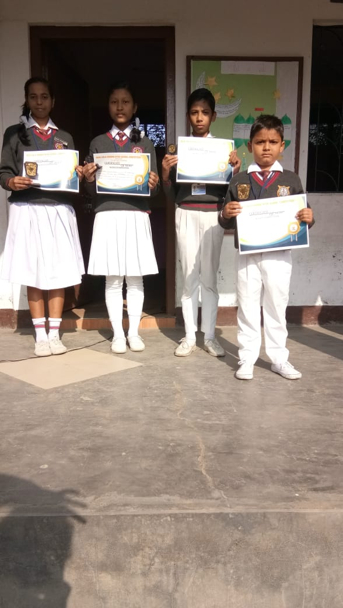
Celebrations – Our school celebrated the 26th January and 15th August ceremony on the school along with the sports and PT teacher. Students and teachers came to the school early morning at around 7 o’ clock for the flag hoisting. Flag hoisting was done at around 7.15 after that it was followed by the March Past and National Anthem. After the flag hoisting students and teachers gave their speech related on Independence day.
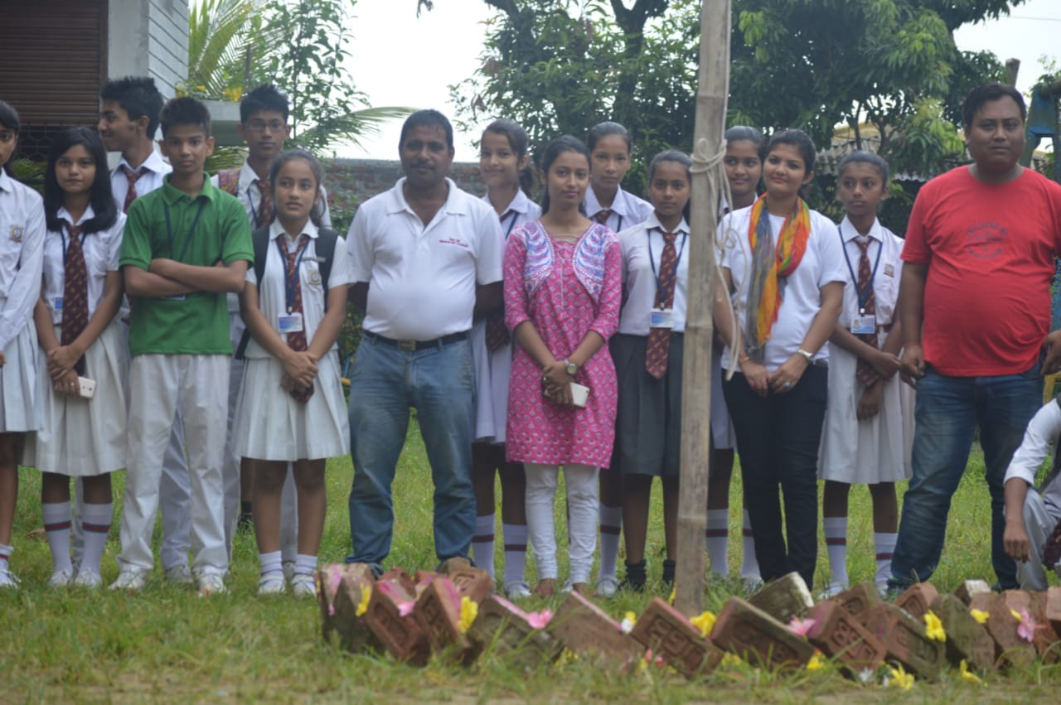
Teachers Day Celebration – Our students celebrated the teacher’s day celebration on 5th September to show their respect to Sarvepalli Radha Krishnan and also to their respected teachers by giving speech, organizing functions etc.
Children’s Day Celebration – Our school organized the Children’s Day celebration where the students were given to speak about Children’s Day celebration importance the reason behind its celebration.Various functions and competitions were also held. After that the children were grouped and asked to share their tiffin with all their classmates, along with the class teacher, so that they can acquire the habit of sharing and caring in future.
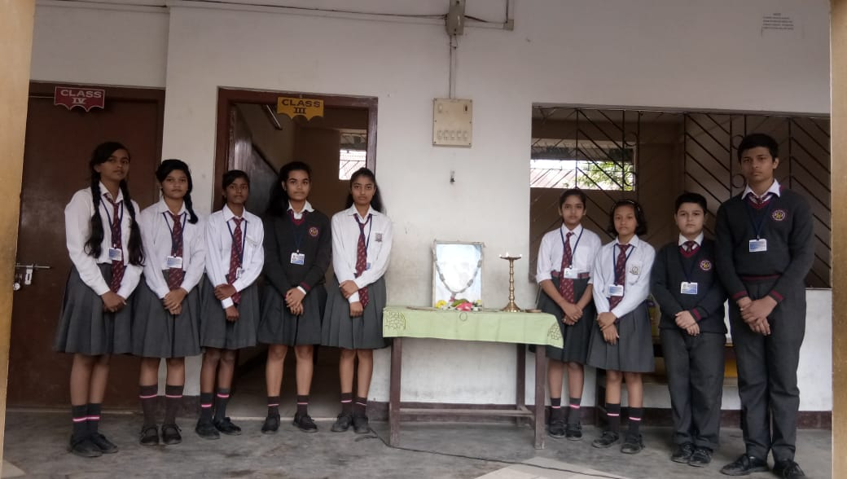

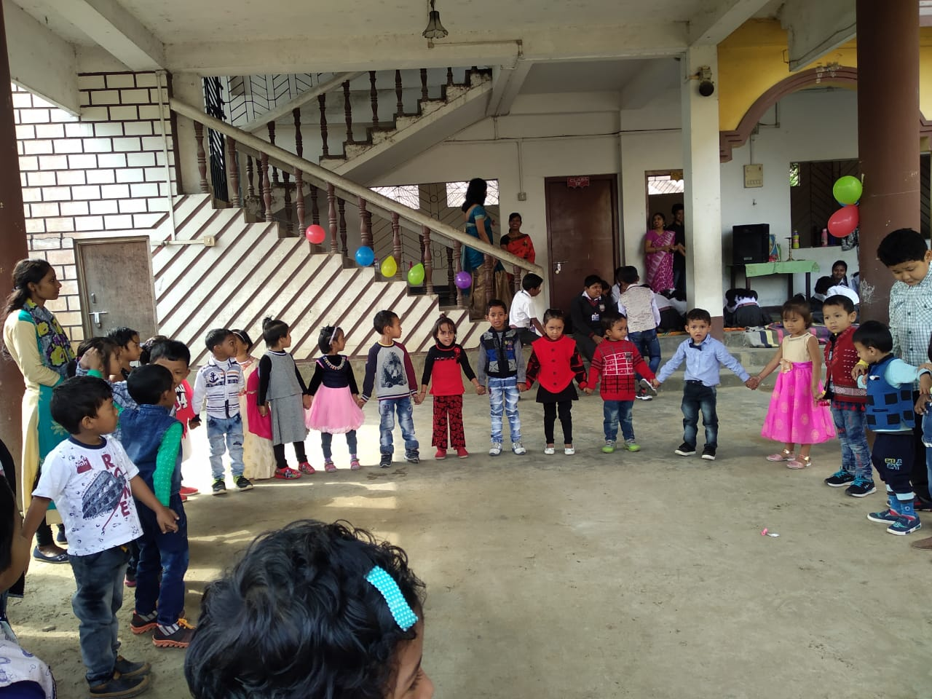

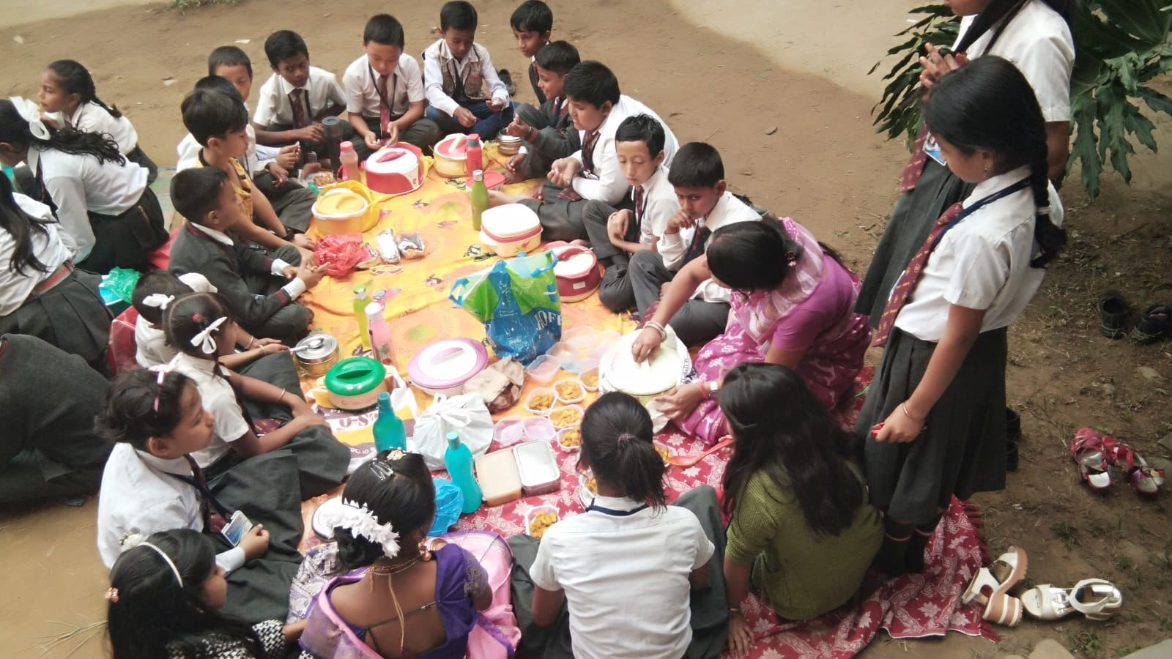
Christmas Day- Our school also celebrated Pre Christmas day celebration on 24th December in the school premises. A skit was performed along with singing and dancing of Christmas carols.
Sports events – Our school sports day was celebrated on the month of March where various games including the Indoor and Outdoor games competitions were held like 100 metre running race, skipping race, marble race, hopping race, balloon race were held for junior section and 400 meter running race, kabbaddi, kho –kho,volley ball , badminton. relay race were held for senior classes where students showed their interest and also gave their level best to win the first and second prizes. All the sports events held helped to garner a feeling of comradeship among all the students of different classes.
There were also some selected events where teachers participated.
Other events- There were other competitions like extempore speech, debate competitions, drawing competitions held to increase the IQ level of the students, also solo dancing, singing competitions, etc. form a part of the curriculum.
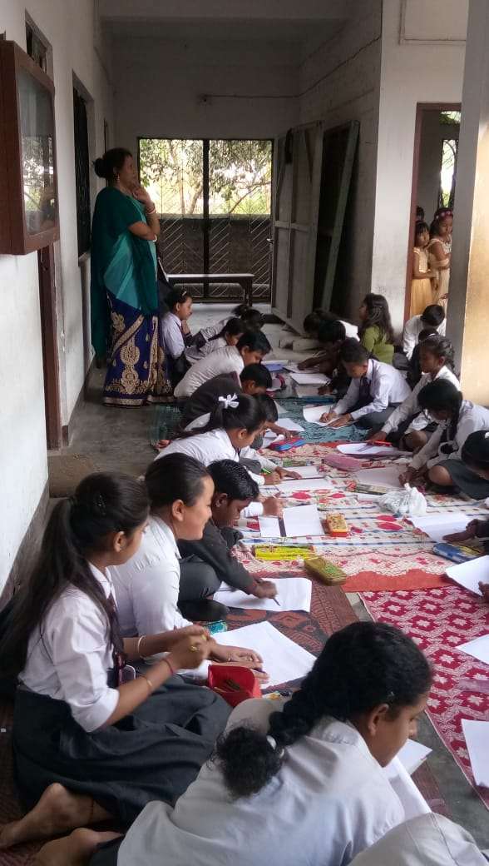
Apart from all these CCA classes are organized in the school on Saturdays where students are taught craft and also guided to make various things making best out of waste, where students are given chance to exhibit their creativity
WORKSHOP- Our teachers also participated in various workshops organized by the CBSE board.
Picnic – A picnic was also organized for the senior students on 6th of January 2019.Teachers of the school also participated with full zeal to make the event successful. The spot was Alubari in Arunachal Pradesh..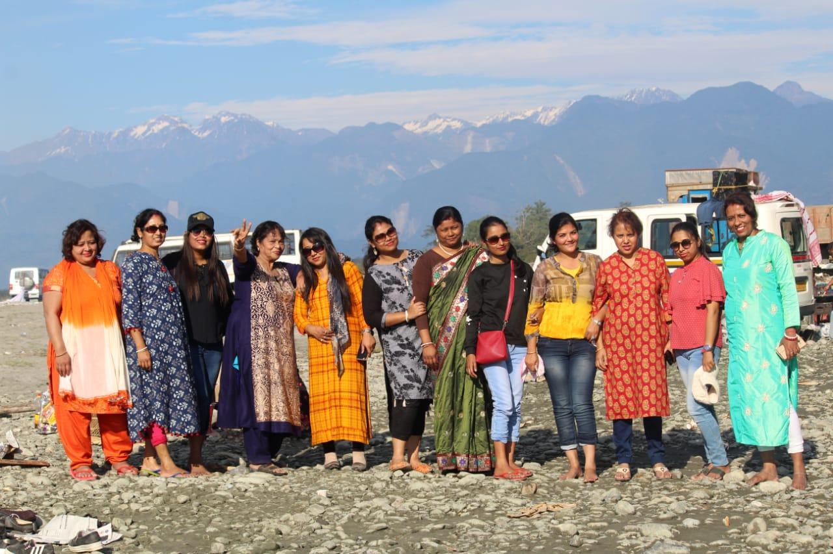
THANK YOU With a deep sense of humility and gratitude I say that we are proud of our work and have a long way to traverse, to reach a goal that is not impossible.

